Relay Driver

ULN2803

The eight NPN Darlington connected transistors in this family of arrays are ideally suited for interfacing between low logic level digital circuitry (such as TTL, CMOS or PMOS/NMOS) and the higher current/voltage requirements of lamps, relays, printer hammers or other similar loads for a broad range of computer, industrial, and consumer applications. All devices feature open–collector outputs and free wheeling clamp diodes for transient suppression.

The ULN2803 is designed to be compatible with standard TTL families while the ULN2804 is optimized for 6 to 15 volt high level CMOS or PMOS.

Features

- Eight darlingtons with common emitters;
- Output current to 500 Ma;
- Output voltage to 50 V;
- Integral suppression diodes;
- Versions for all popular logic families;
- Output can be paralleled;
- Inputs pinned opposite outputs to simplify board layout.
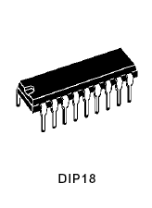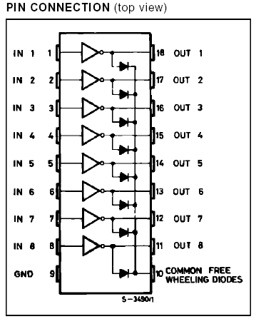

Description

The ULN2801A-ULN2805A each contains eight Darlington transistors with common emitters and integral suppression diodes for inductive loads. Each Darlington features a peak load current rating of 600mA (500mA continuous) and can withstand at least 50V in the off state. Outputs maybe paralleled for higher current capability.

Five versions are available to simplify interfacing to standard logic families: the ULN2801A is designed for general purpose applications with a current limit resistor; the ULN2802A has a 10.5k input resistor and zener for 14-25V PMOS; the ULN2803A has a 2.7k input resistor for 5V TTL and CMOS; the ULN2804A has a 10.5k input resistor for 6-15V CMOS and the ULN2805A is designed to sink a minimum of 350mA for standard and Schottky TTL where higher output current is required. All types are supplied in an 18-lead plastic DIP with a copper lead from and feature the convenient input opposite-output pinout to simplify board layout.

